# **Name: Abdurrahman Qureshi**

# **Roll No: 210451**

Practical No: 2

**1)Create the following output**

**CODE:**

import java.applet.*;

import java.awt.*;

// <applet code="Main" height=200 width=200></applet>

public class Main extends Applet {

Label l2;

List c1, c2, c3;

public void init() {

l2 = new Label("Abdurrahman Qureshi - 210451");

c1 = new List(3);

c1.add("Summer");

c1.add("Winter");

c1.add("Rainy");

add(l2);

add(c1);

}}

**OUTPUT:**

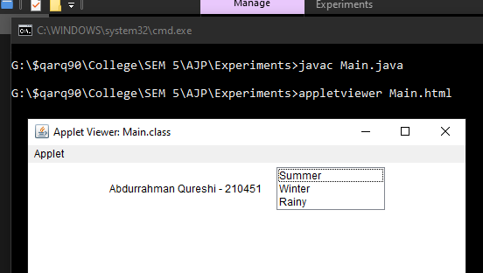

**2)Add ten cities to a list component**

**CODE:**

import java.applet.*;

import java.awt.*;

import java.util.ArrayList;

// <applet code="Main" height=200 width=200></applet>

public class Main extends Applet {

ArrayList A;

Label l2;

List c1, c2, c3;

public void init() {

l2 = new Label("Abdurrahman Qureshi - 210451");

c1 = new List(10);

c1.add("Mumbatten");

c1.add("Gotham");

c1.add("Oz");

c1.add("Dressrosa");

c1.add("Konoha");

c1.add("Marley");

c1.add("Alabasta");

c1.add("Sydney");

c1.add("Moscow");

c1.add(String.valueOf(A));

add(l2);

add(c1);

}

}

**OUTPUT:**

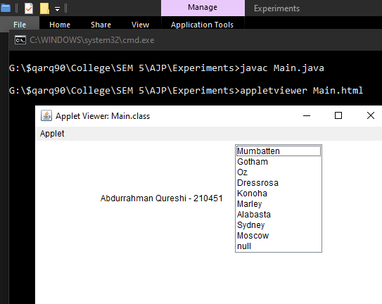

**3)Select multiple newspaper names**

**CODE:**

import java.applet.*;

import java.awt.*;

// <applet code="Main" height=200 width=200></applet>

public class Main extends Applet {

Label l2;

List c1, c2, c3;

public void init() {

l2 = new Label("Abdurrahman Qureshi - 210451");

c1 = new List(10, true);

c1.add("The Times of India");

c1.add("The washington Post");

c1.add("The New York Times");

c1.add("The Economic Times");

c1.add("The Guardian");

c1.add("The Inquilab");

c1.add("The Rolling Post");

add(l2);

add(c1);

}

}

**OUTPUT:**

